Bước 1: Dowload VisualSVN Sever

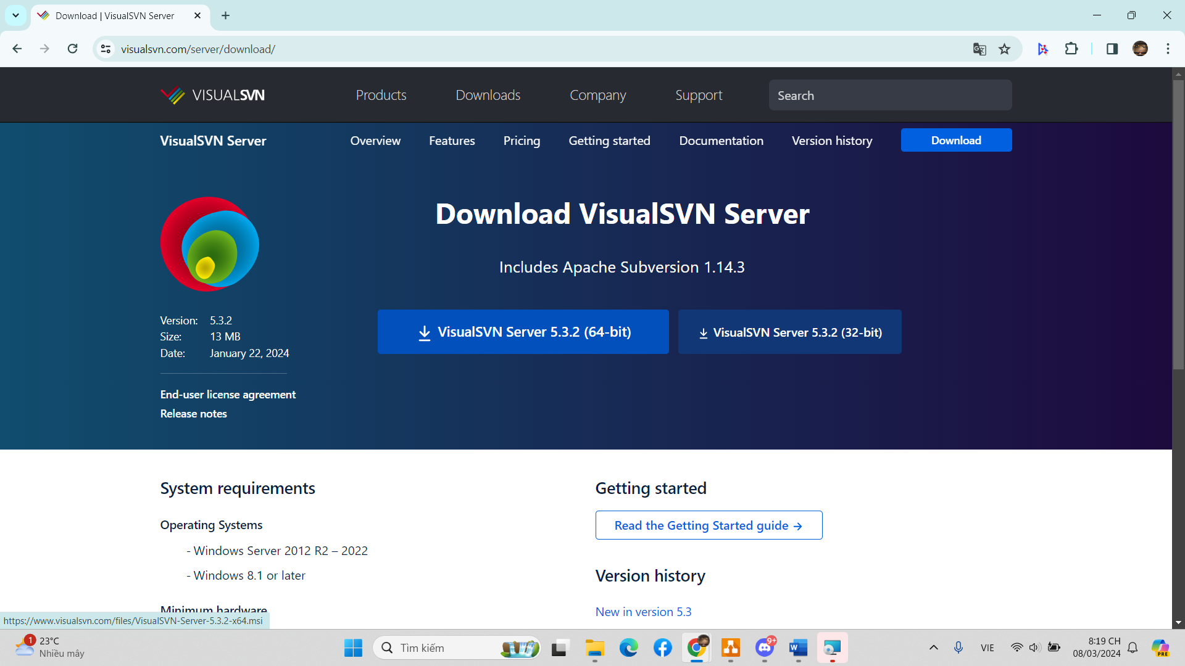

Bước 2: Creat Repositories

* Right click Repositories -> Click Creat New Repositories

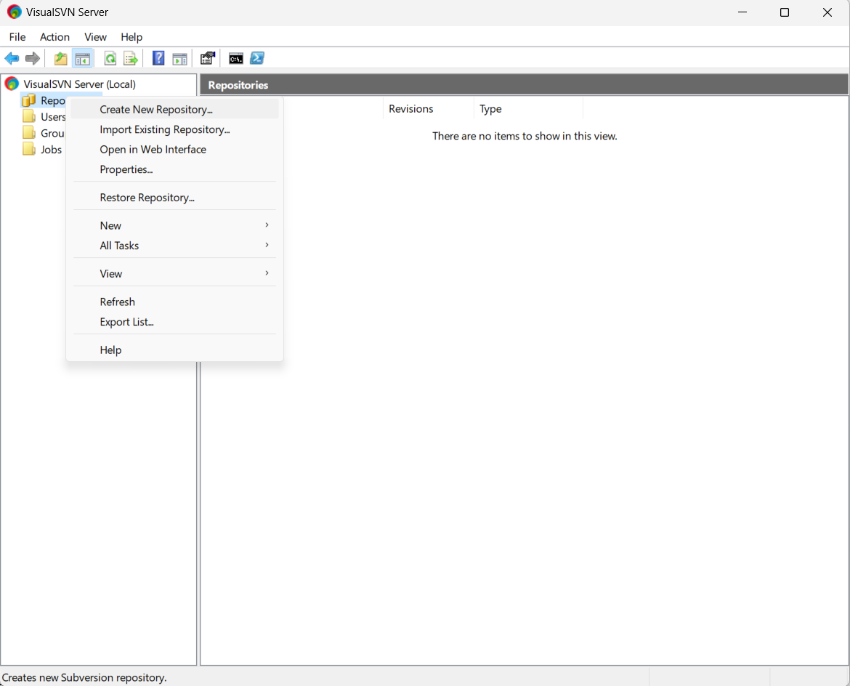

* Enter name and press “ Next”

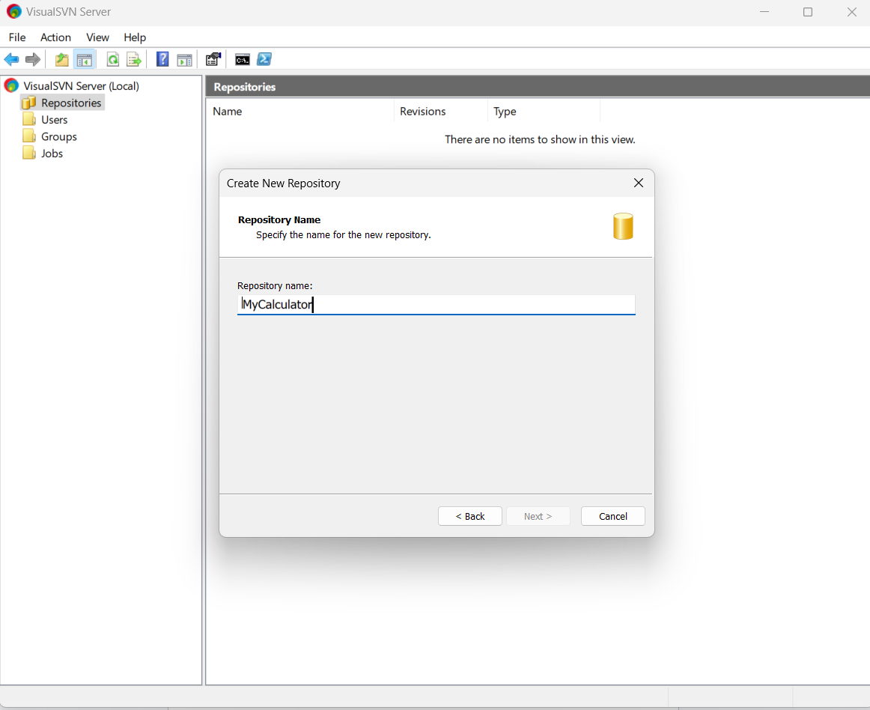

* Select the preferred initial repositories structure -> Press “Next”

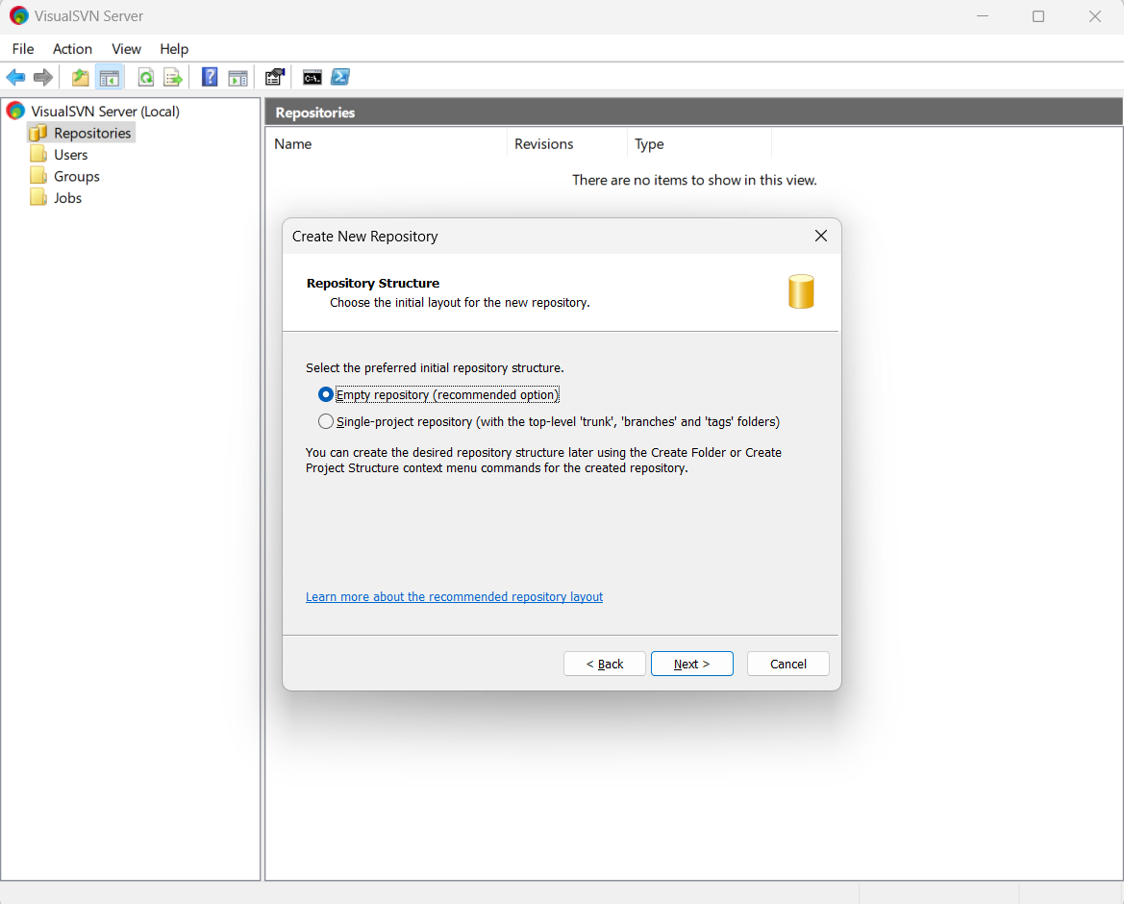

* Set the kind of permissions you want for the new repository -> Press “Next” -> Press “Creat”

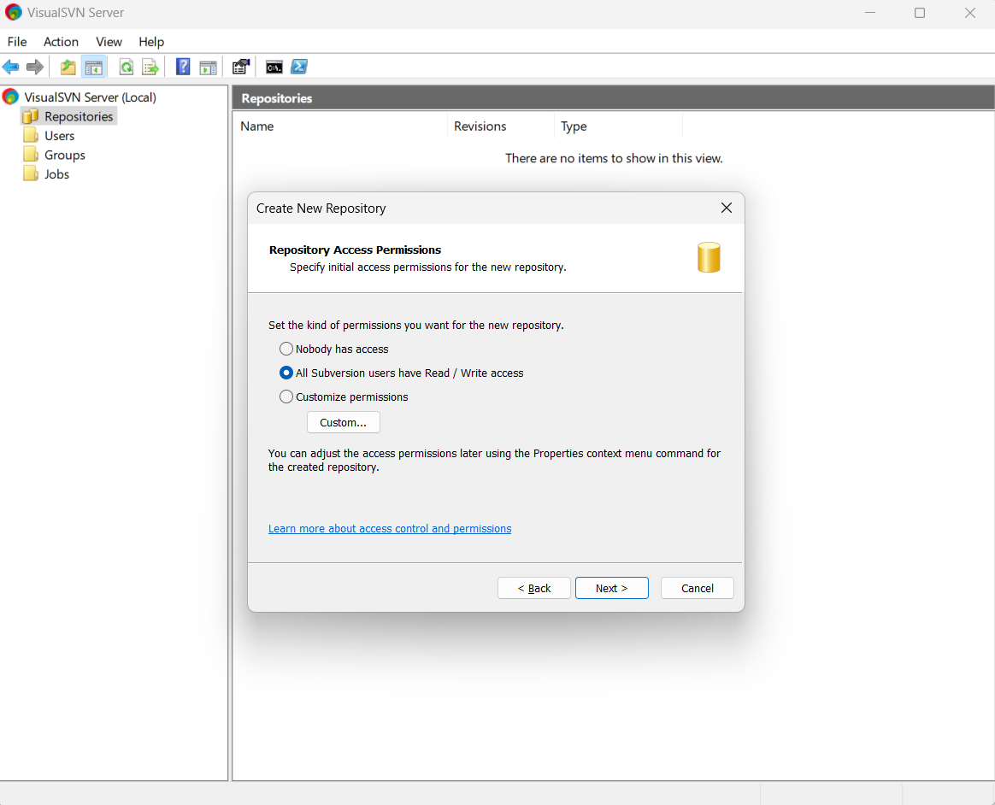

Bước 3: Right click the “User” -> Click “ Creat User”

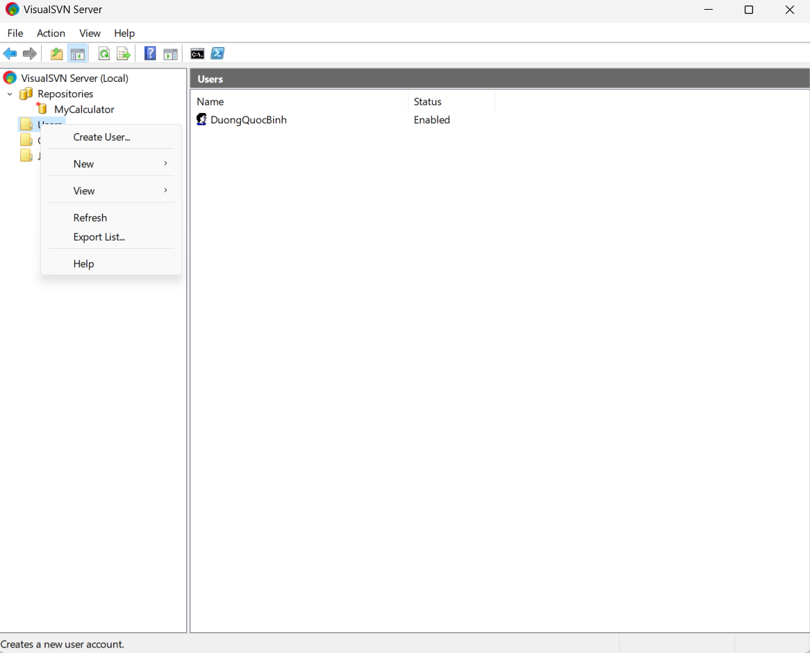

Bước 4: Enter the user name and password -> Press “Ok”

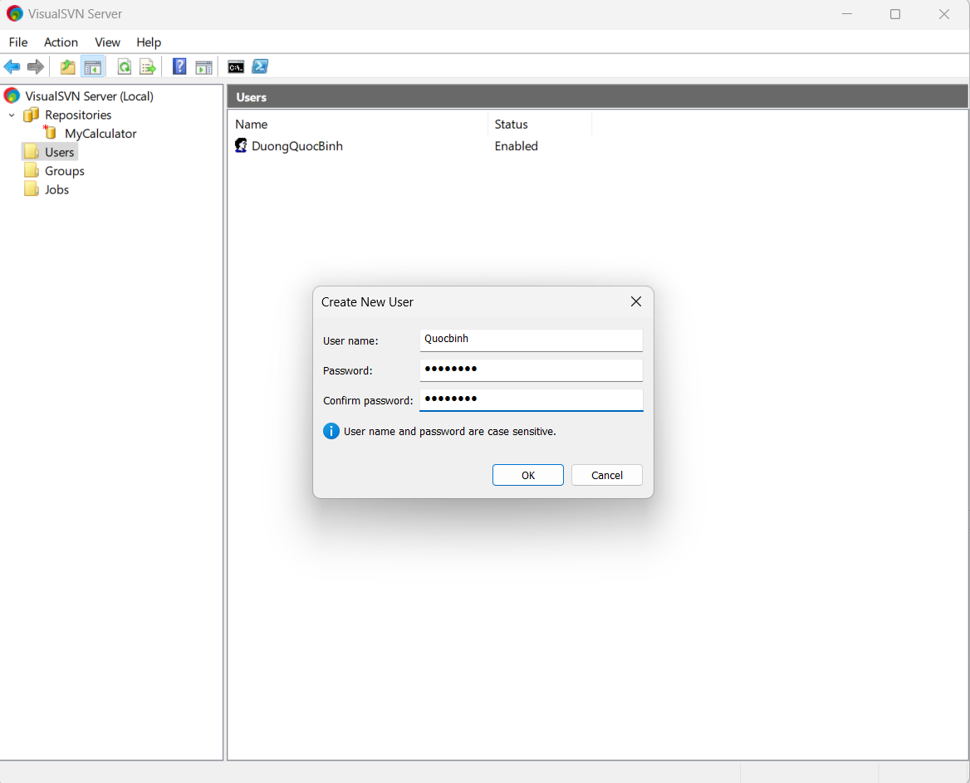

Bước 5: Right click “Groups” -> Click “Creat Group”

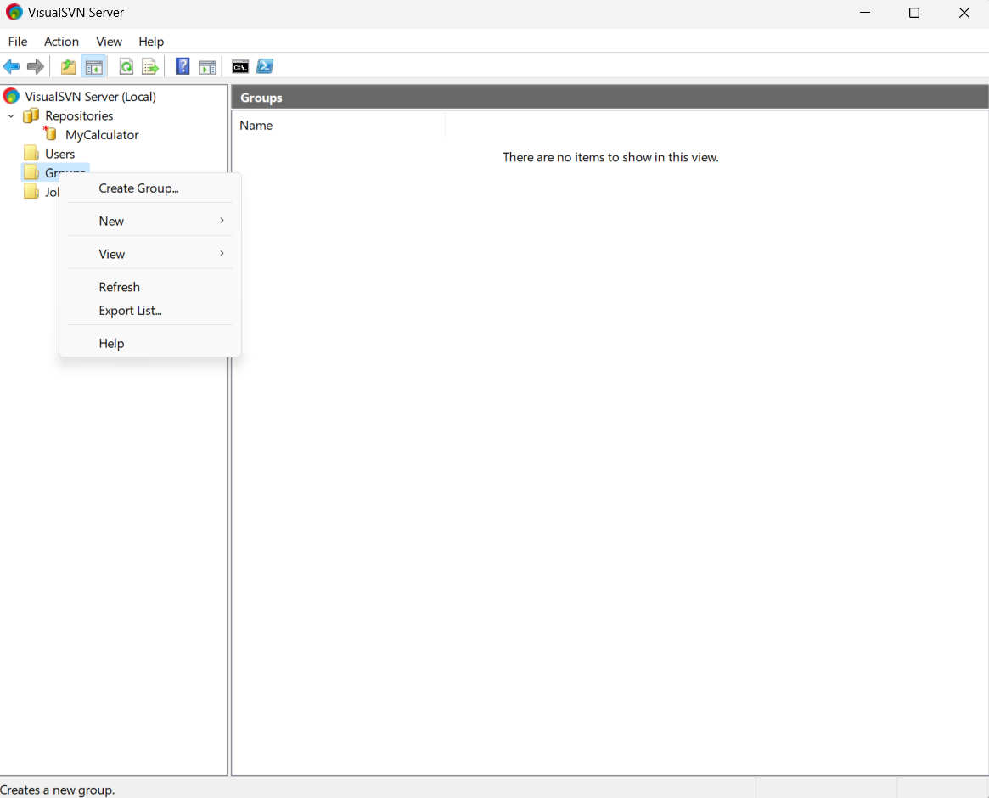

Bước 6: Enter the name group -> Press “Add member” -> Press “Ok”

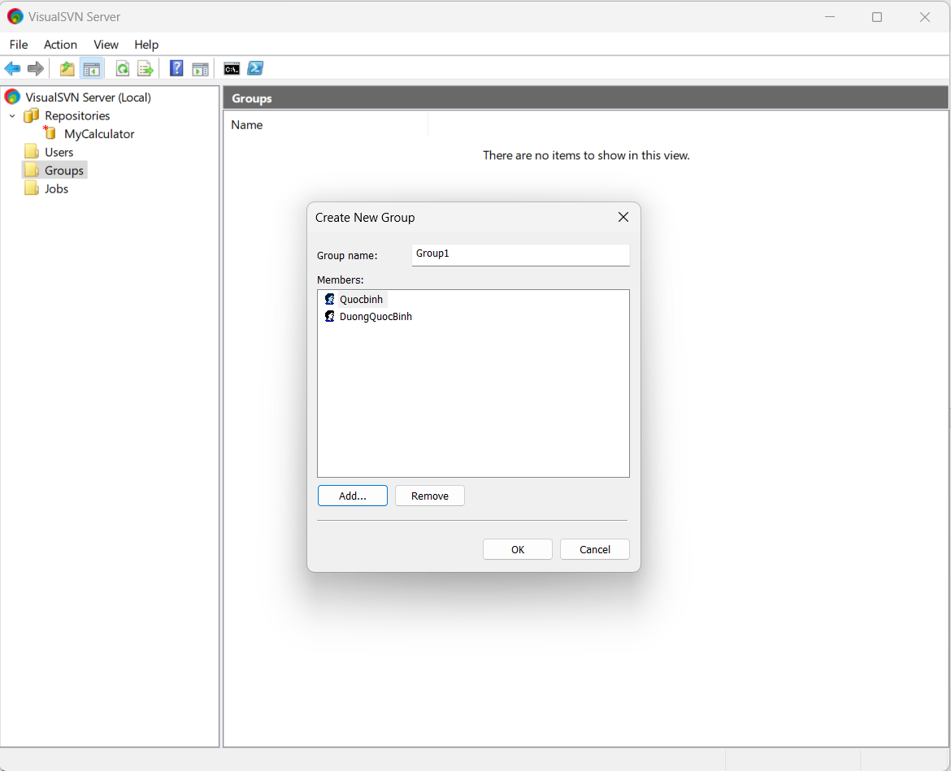

Bước 7: Right click your repositories -> Press “All task” ->Press “Manage Security”

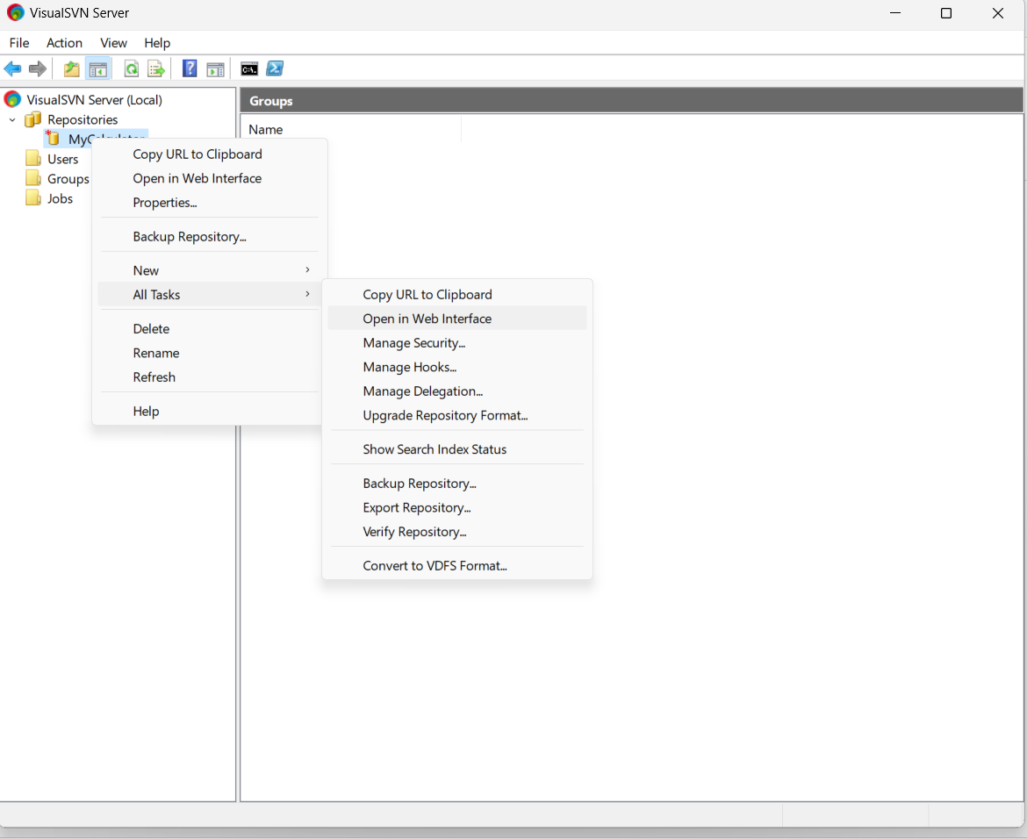

Bước 8: Choose member and add -> Choose permissions for them -> Press “Ok”

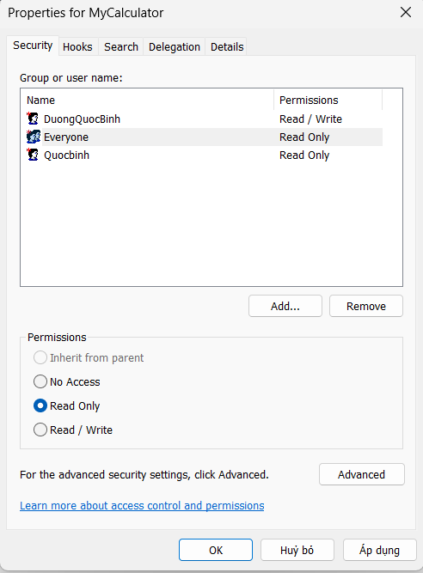

Bước 9: Install Subversive Plugin on Eclipse:

* On Eclipse app -> Click “Help”-> Click “ Eclipse Marketplace” -> Search “ Subversive SVN ” in search box -> Install

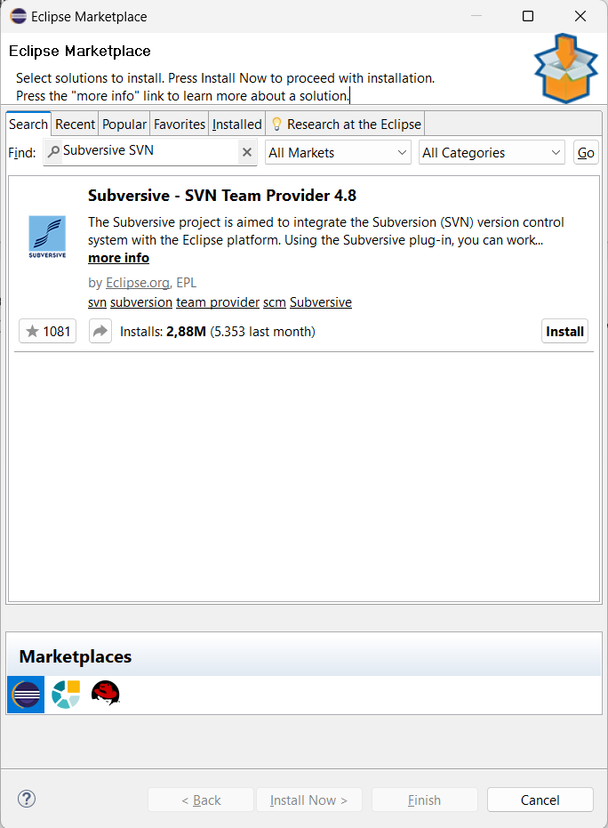

Bước 10: Right click -> Open in Web Interface

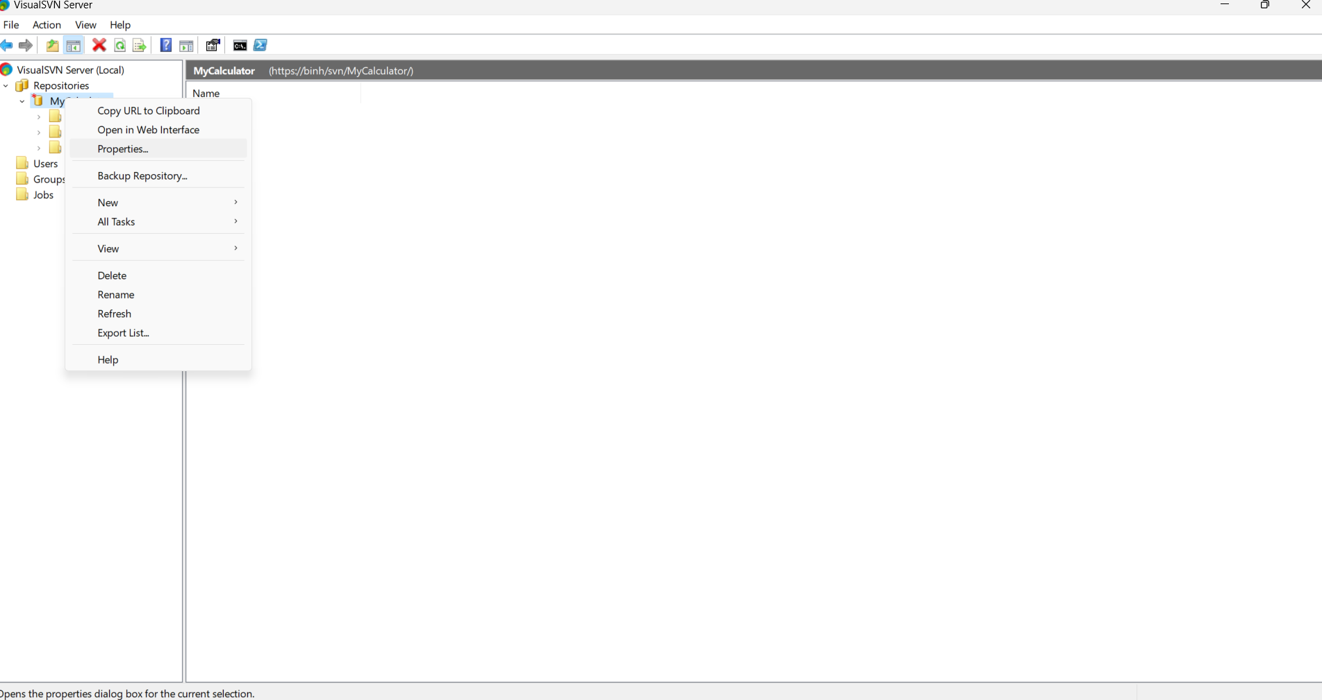

Bước 11: Choose file and upload file -> Commit change

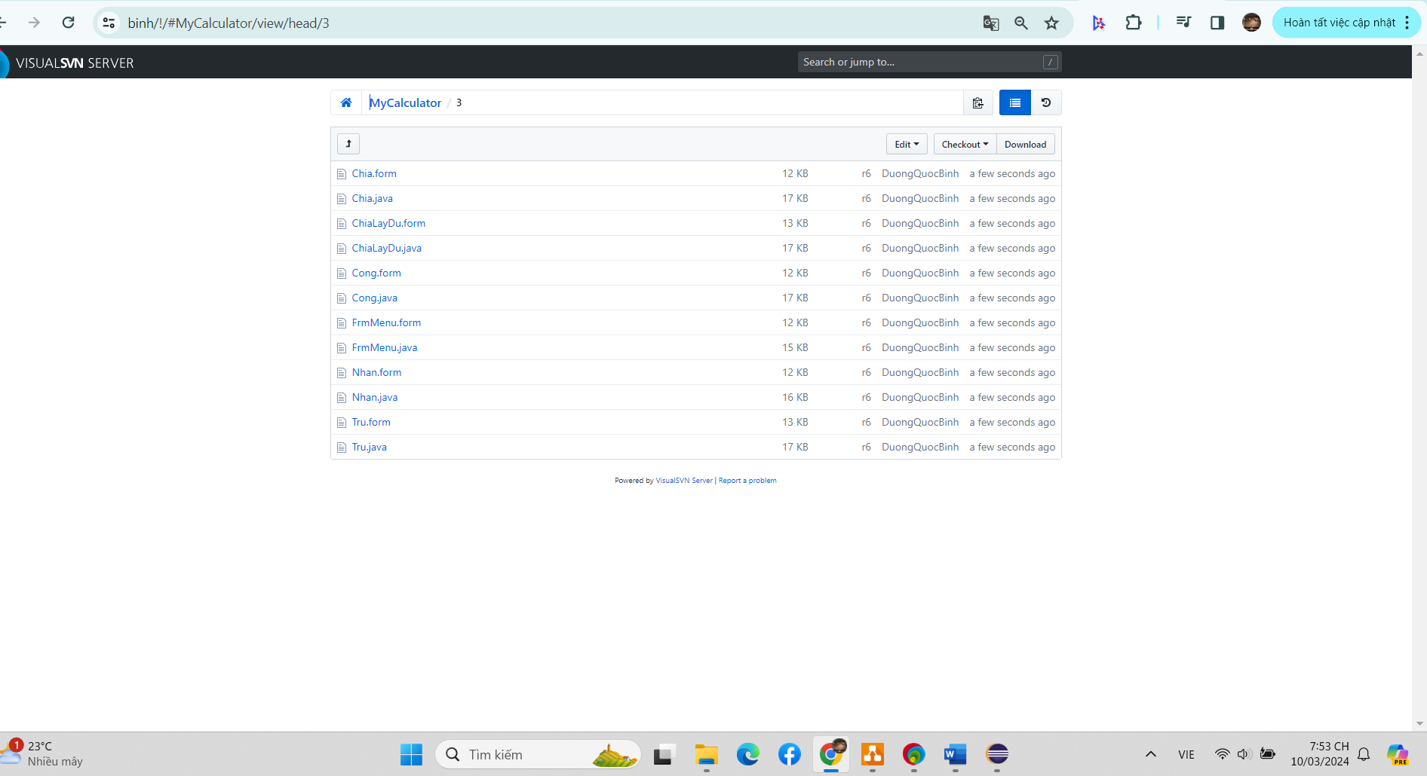

Bước 12: Check out

* Right click -> Press Import -> SVN ->Check out Project from SVN –> Next

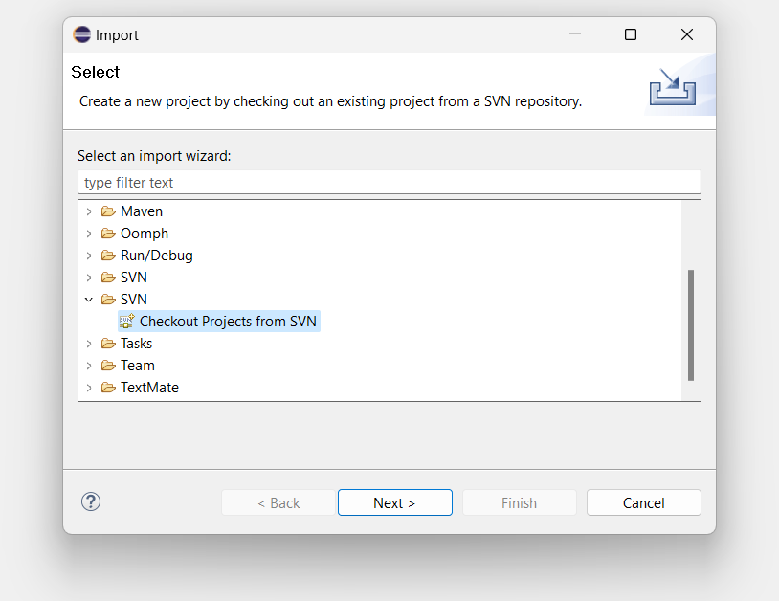

* Choose link -> Next -> Java Project -> Next

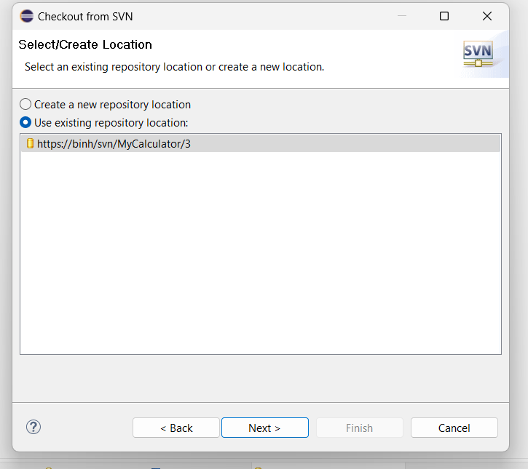

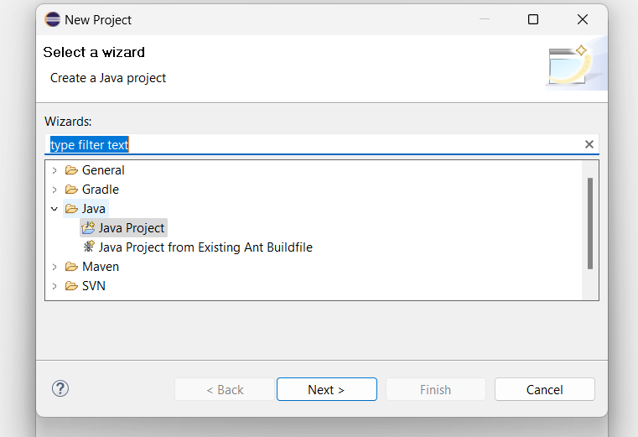

* Enter name project -> Next -> The new Project will appear

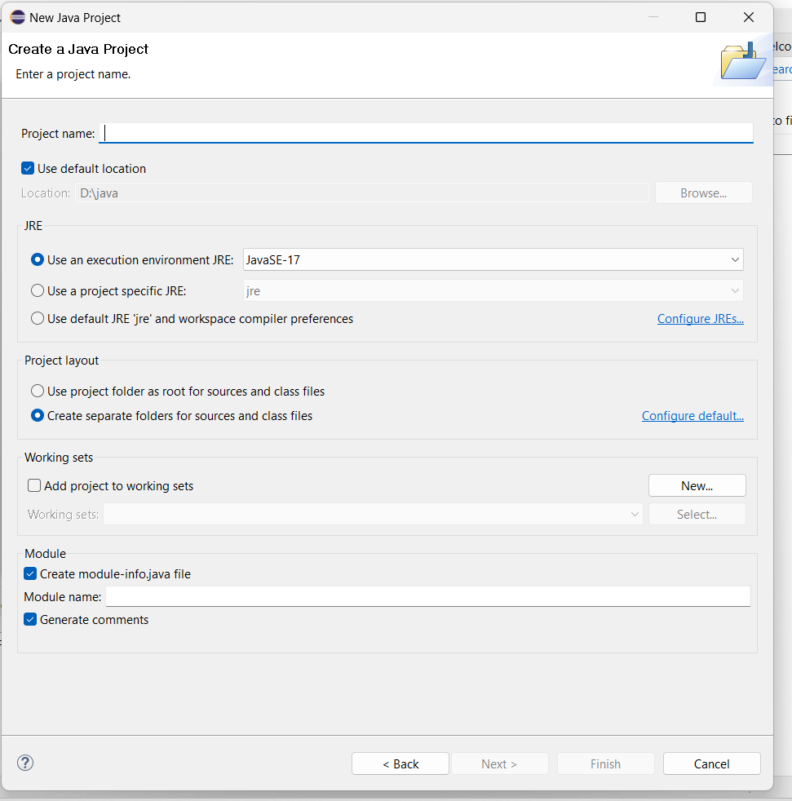

* Right click new project -> Team -> Commit to save changes to SVN server

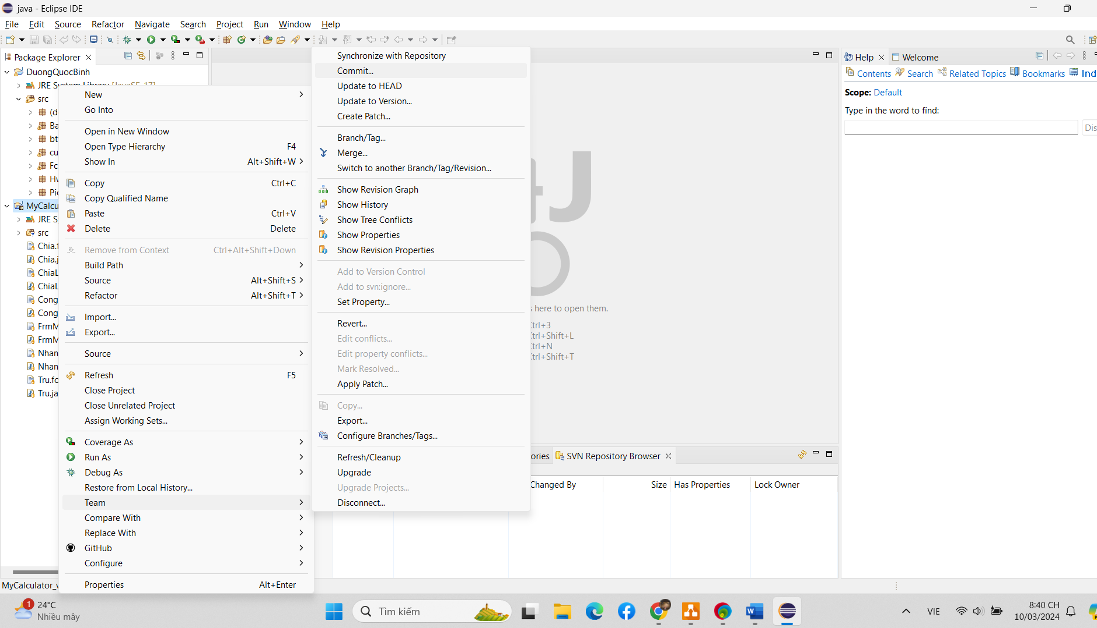

* When editing, access folder "1" on the SVN server to edit,fix errors and update the software to make it more complete and then put it into use.
* Right click again on the folder "MyCalculator [3]" -> Team-> Branch/Tag.. -> change the link to "..1" to create the folder "1" in SVN server->Next- >Finish.
* Delete file "1" on SVN sever first.

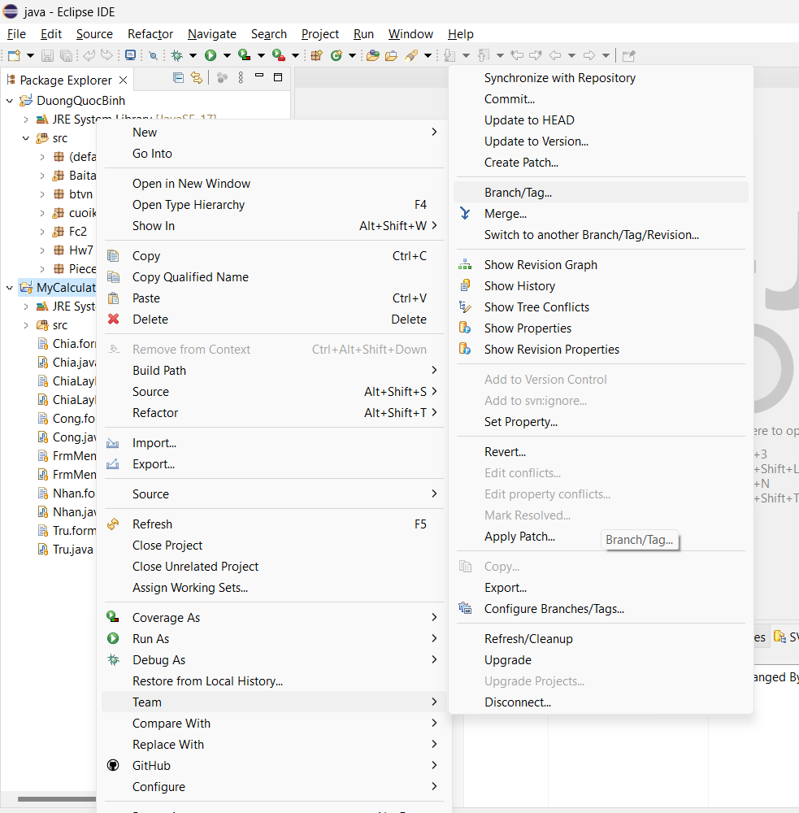

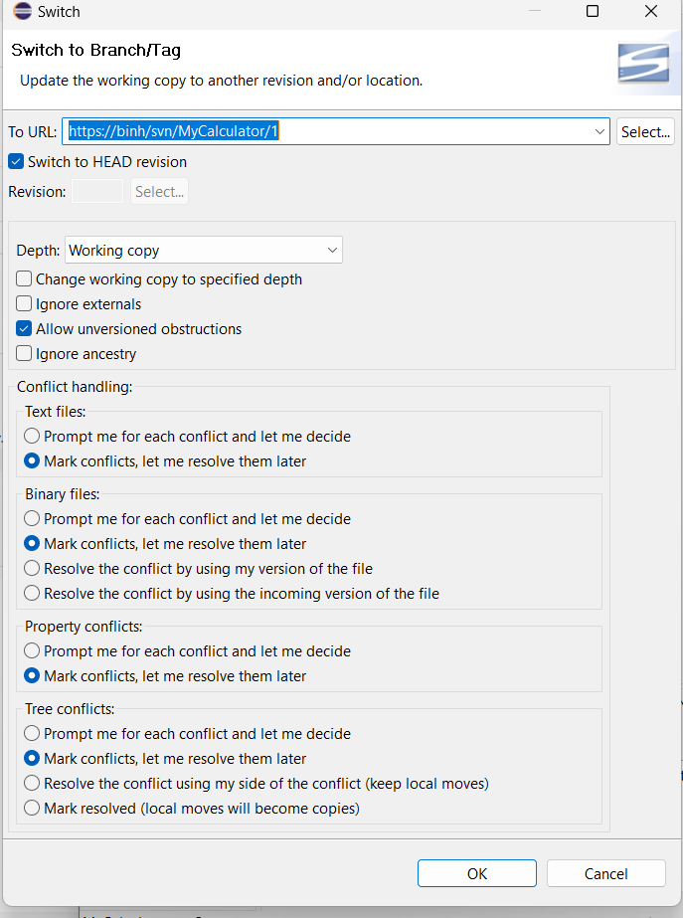

Bước 13: Use Tortoise SVN for check out

* Dowload Tortoise SVN

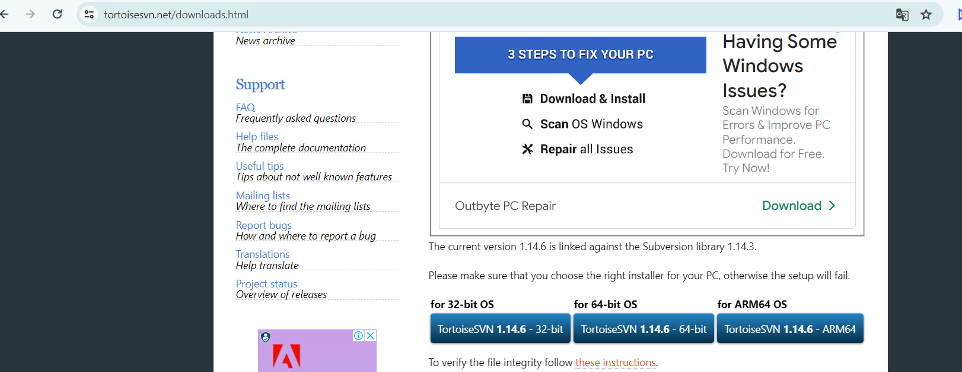

* Right click -> Tortoise SVN -> Check out

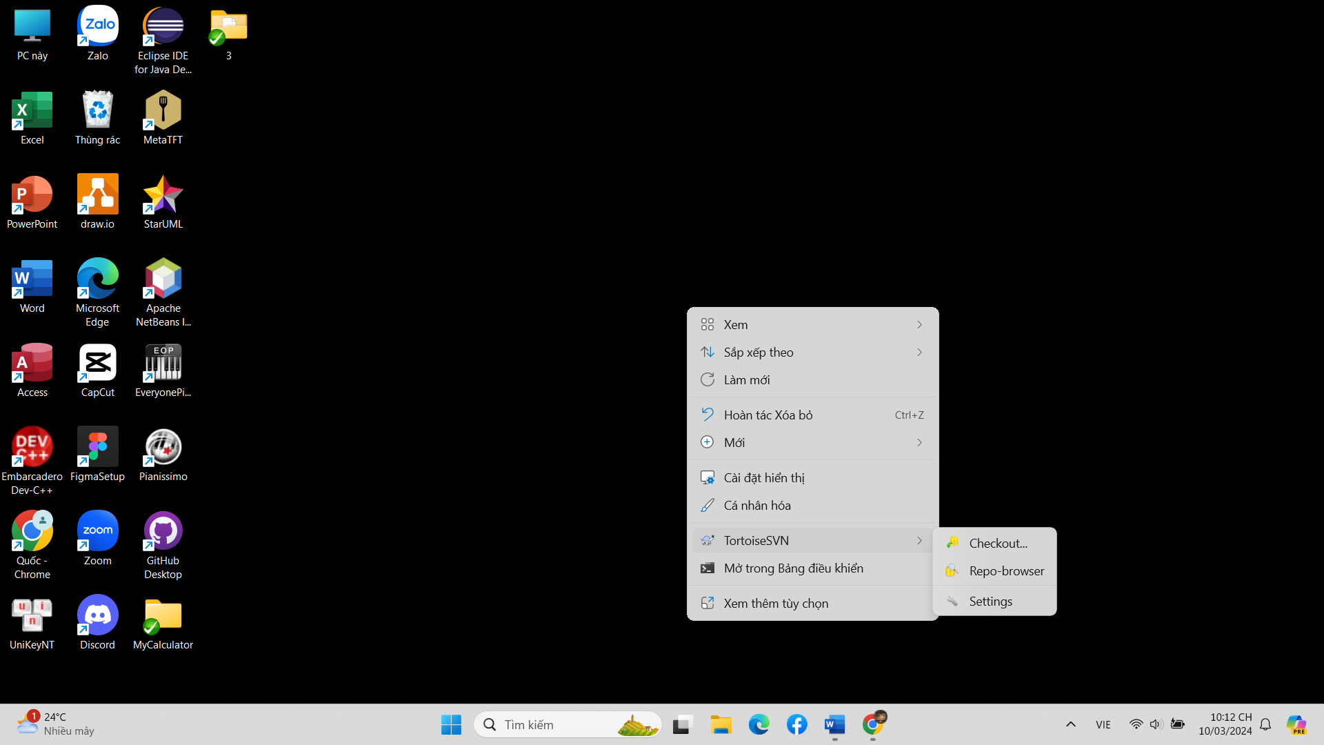

* Copy the path of the directory repository created from the SVN server as below->OK

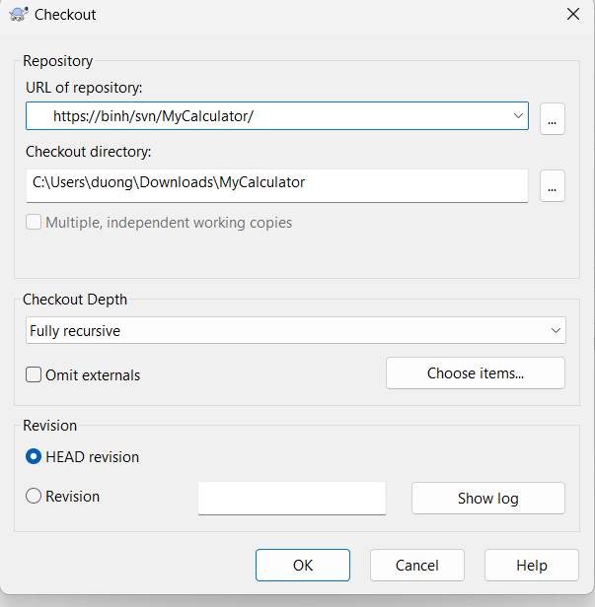

* Once done, the items will be displayed as shown below. There are sections "3" to edit, section "1" to save the original and previous versions, after modifications. 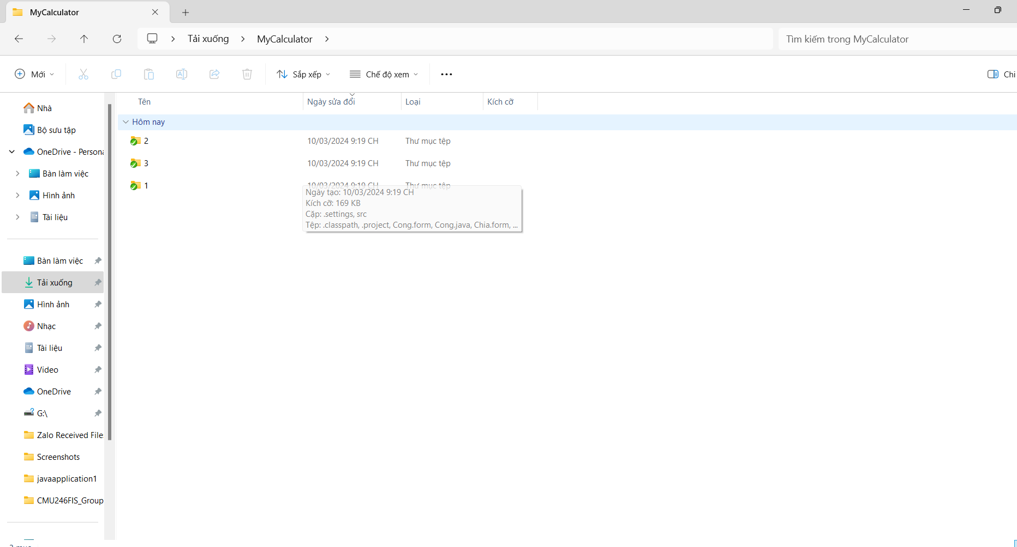
* Make the corrections in section "3"
* Once done, right click item "3" -> Tortoise -> Commit -> Ok to save the changes.

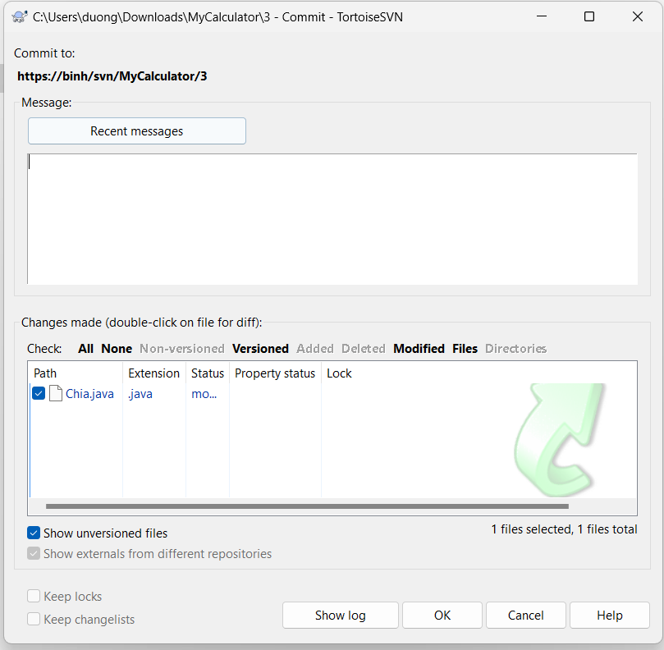

Bước 14: Merge

* Right click item “1” -> Tortoise SVN -> Merge -> Next

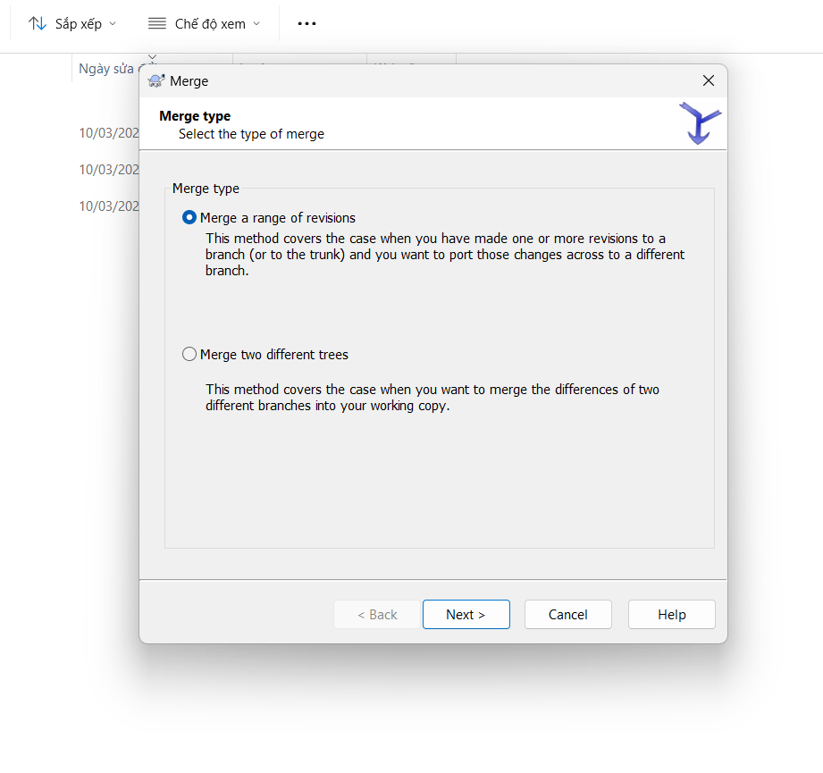

* Change the link to the directory -> Next

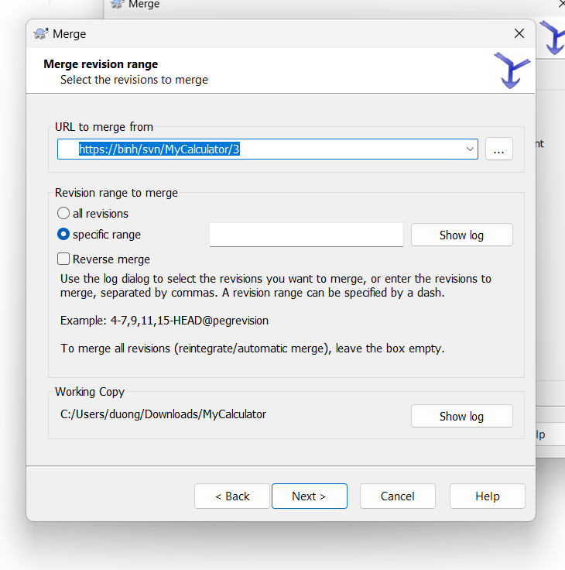

* Click show log to select the version suitable with "1" -> Ok -> Next -> Merge

